Urban Tourism Optimizer
High Level Design Document

1. System Overview
Urban Tourism Optimizer is an intelligent system that generates optimized travel itineraries based on user preferences, constraints, and real-world data such as traffic and weather.

2. Architecture Diagram
2.1 High-Level Architecture
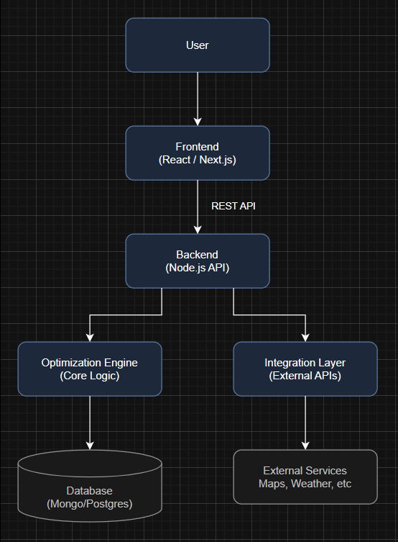

3. Component Diagram
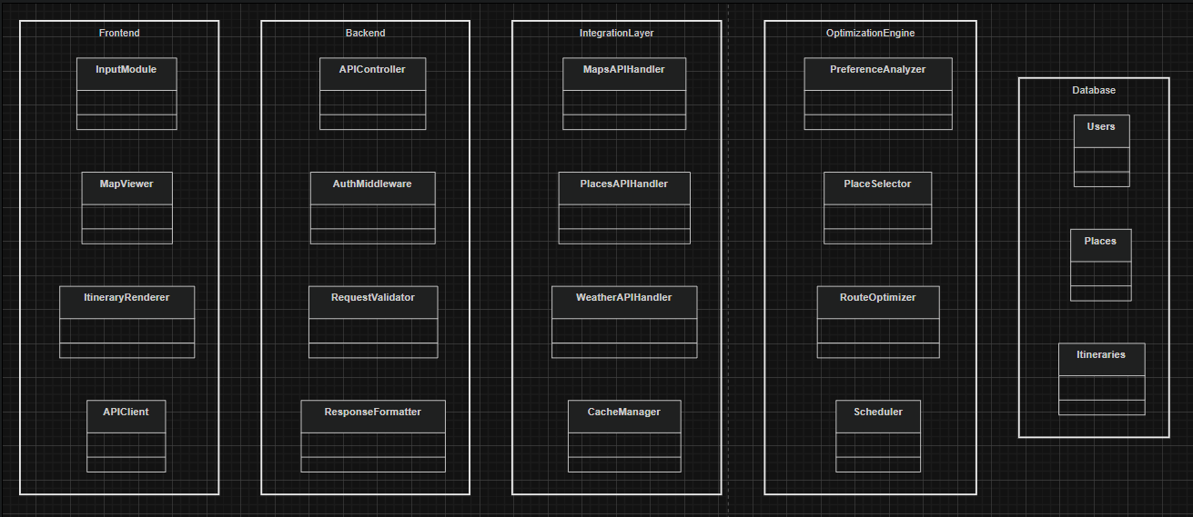

4. Data Flow Diagram (DFD)
4.1 Level 0 (Context Diagram)
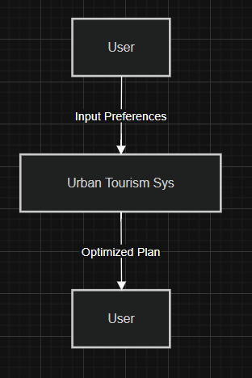

4.2 Level 1 DFD
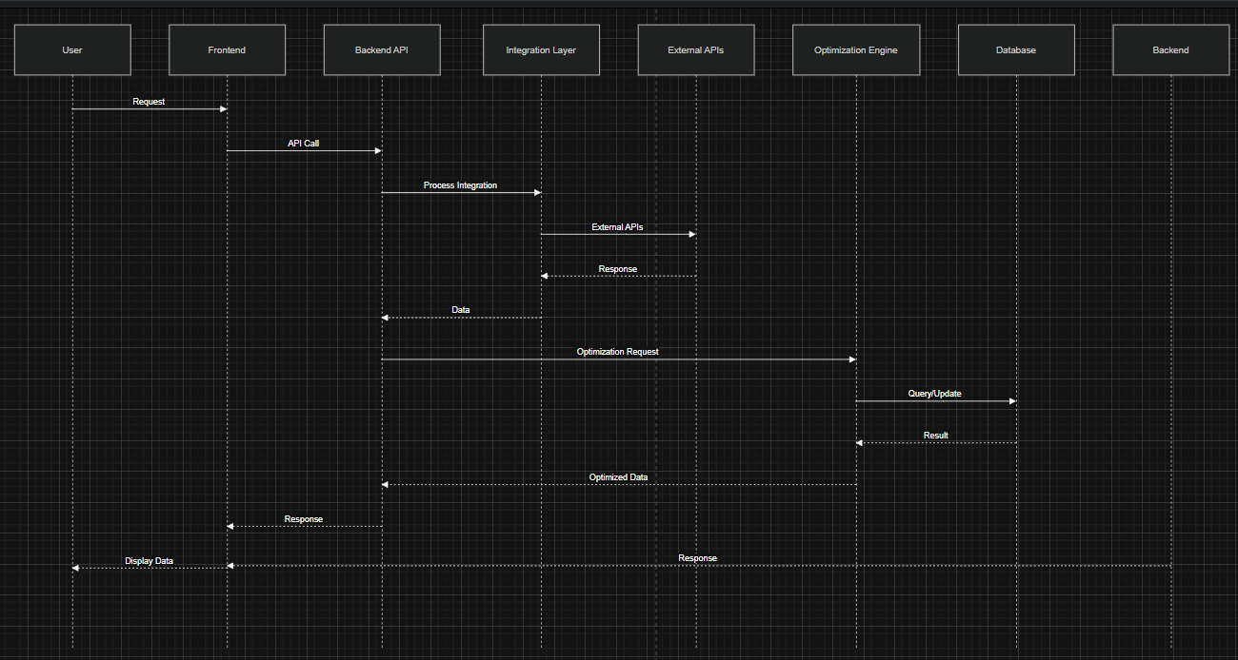

5. Sequence Diagram
5.1 Itinerary Generation Flow
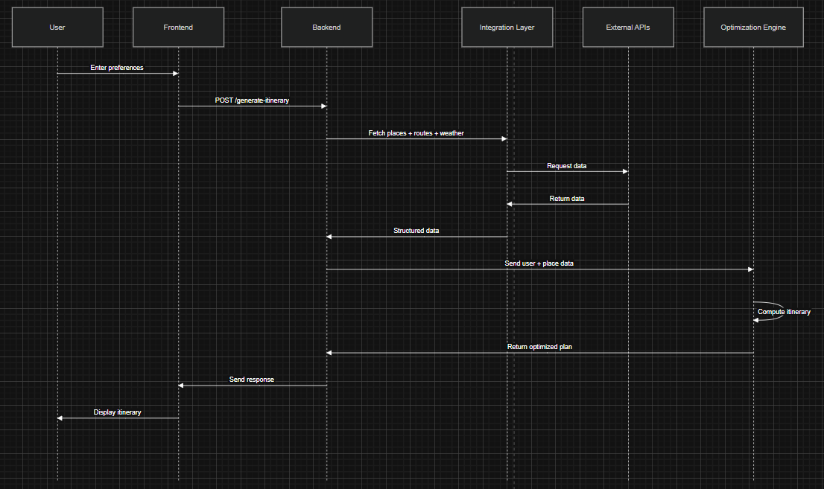

6. Deployment Diagram


7. Data Model (High-Level)
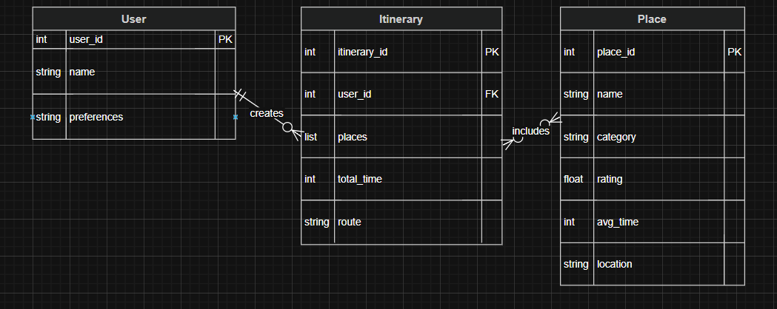

8. Key Design Decisions
- Modular separation of:
  - UI
  - Logic
  - Optimization
  - External integration
- Optimization engine isolated
→ Enables future AI/ML upgrades
- Backend as orchestrator
→ Clean control flow

9. Assumptions
- External APIs are available and reliable
- User provides accurate preferences
- Initial version uses simplified optimization

10. Constraints
- API rate limits
- Real-time data variability
- Limited dataset in MVP phase

11. Future Enhancements
- ML-based recommendation system
- Crowd density prediction
- Booking integration
- Offline itinerary mode

